**Git: https://github.com/anderrekalde/POPBL__v2**

**First Scanner:** this is the result

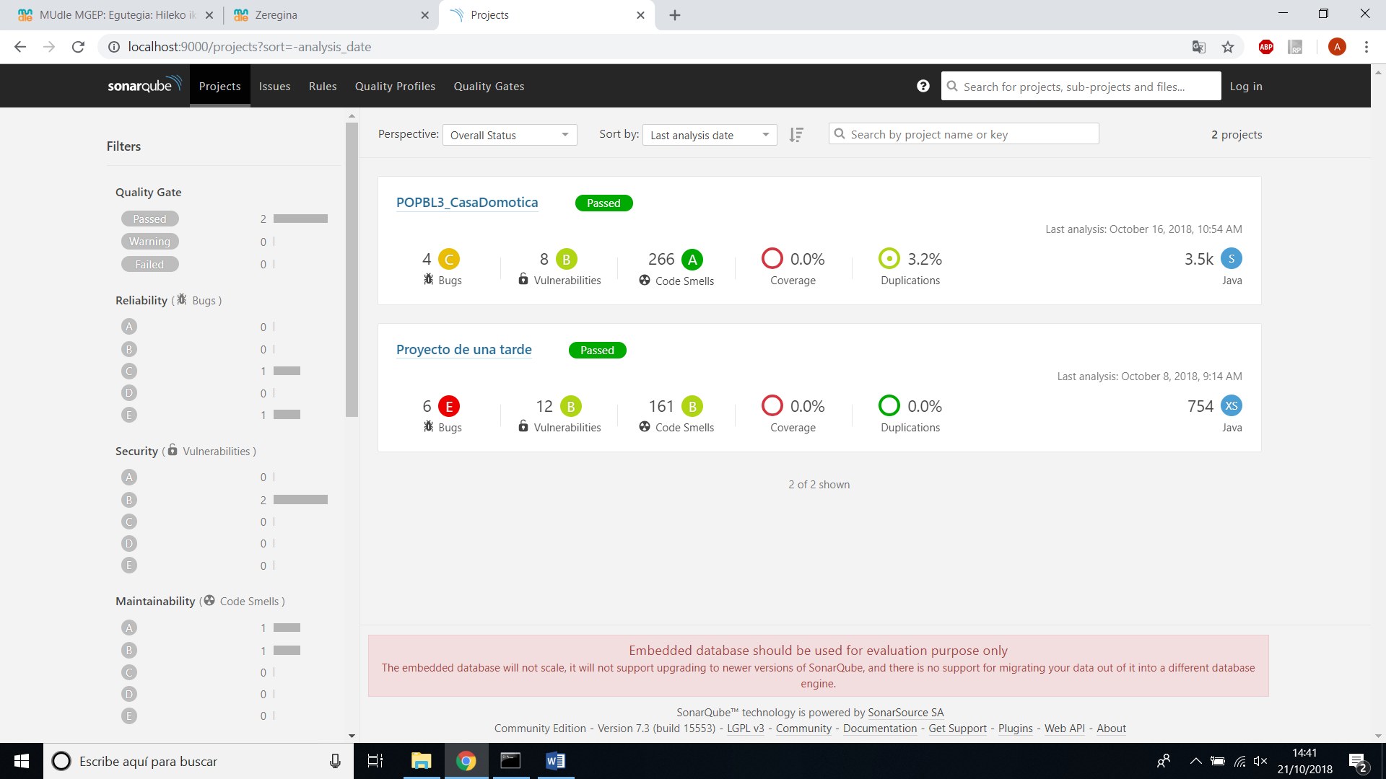

Bugs: Vulnerabilities: the same in all vulnerabilities.

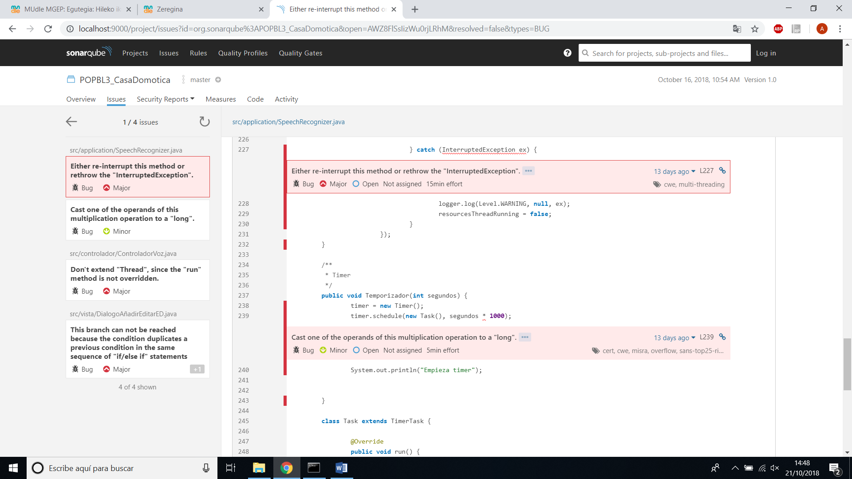 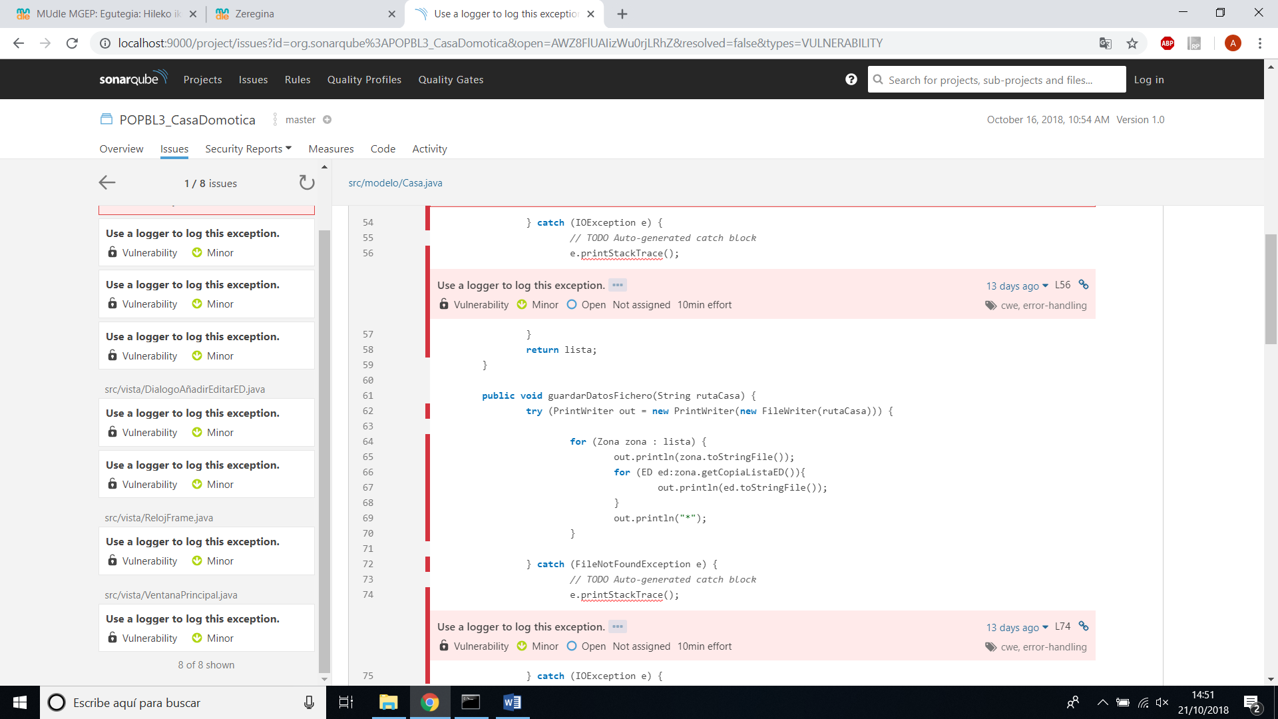

Maintainability: i have 35 files, and 27 are A rating.

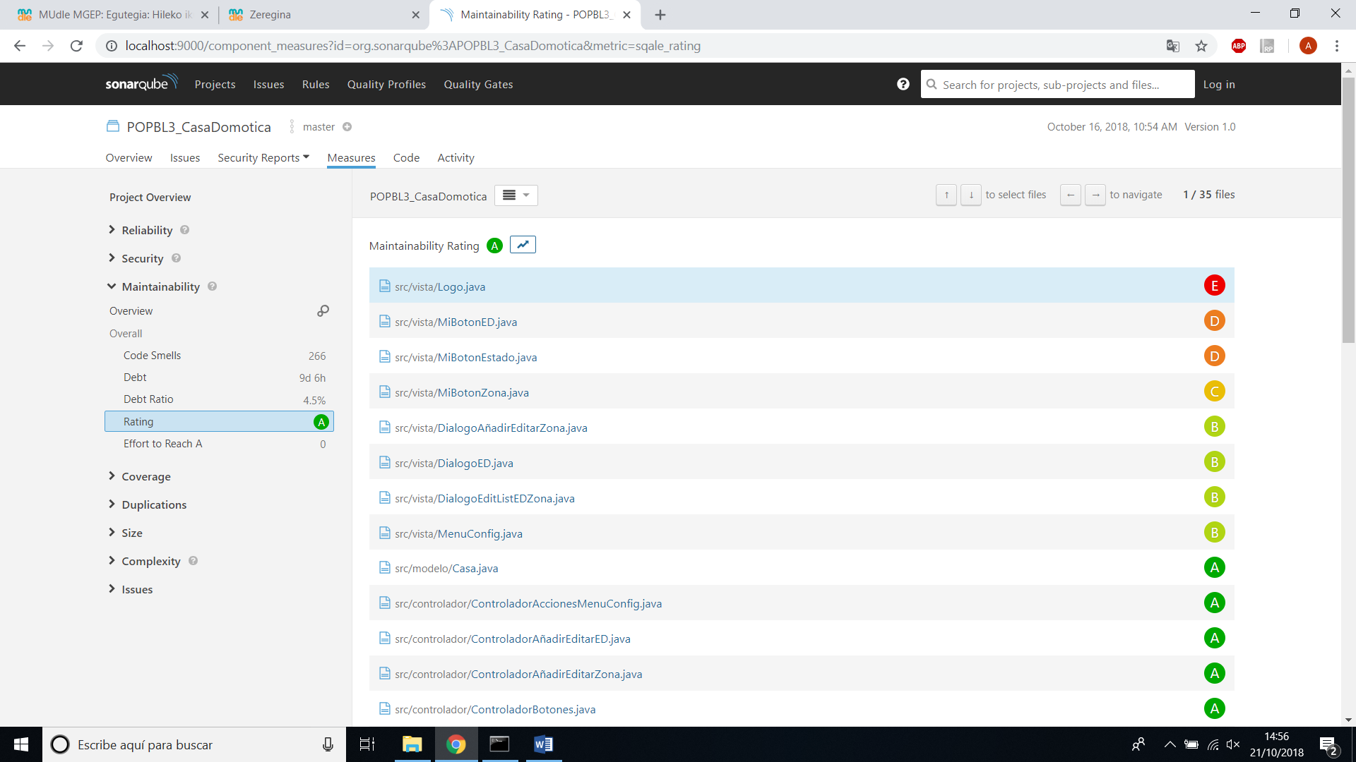

Almost all the files have the same problem: they superate the 5 parents authorization.

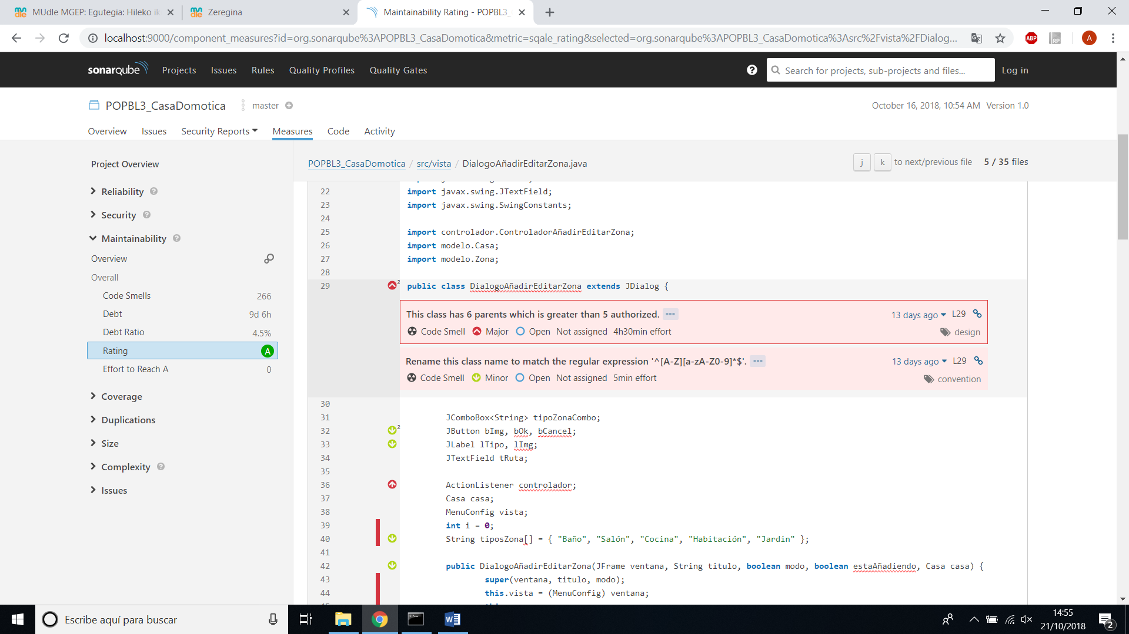

**Second Scanner:** this is the resulto of the second scanner, as you can see I reduced to 0 bugs, 0 bulnerabilities and code smell from 266 to 139.

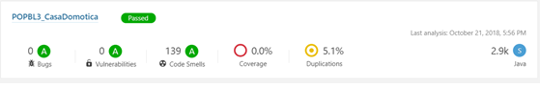

The maintainability also has been imporbed, from 27 with ‘A’ rating to 34.

